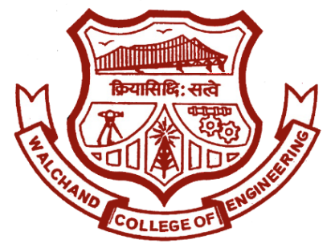

Walchand College of Engineering, Sangli.

(An autonomous institute)

&

Electronics Engineering Students’ Association

(ELESA)

Website: [www.elesa.co.in](http://www.elesa.co.in)

Email: walchand.elesa@gmail.com

ELECTROVERT 2018

EVENT STRUCTURE

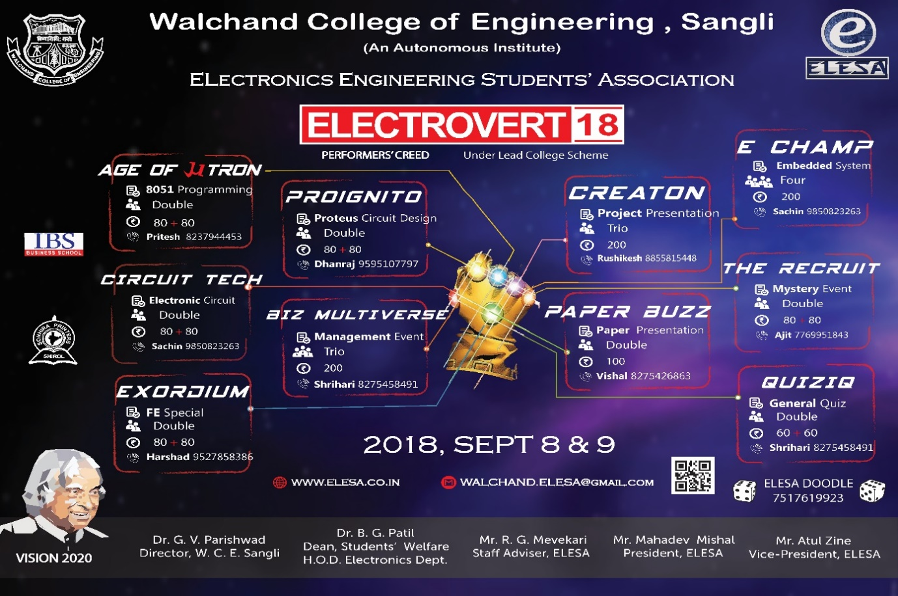

About Electrovert

**ELECTROVERT** is a **State Level Event** organised for engineering and technology students by ELESA, a technical club of dept. of Electronics at Walchand College of Engineering, Sangli. It entails **Technical, Management and soft skills competitions** to provide a better platform to showcase talent for engineering and technology students across the Maharashtra. The students from other universities and colleges participate in the event like Govt. College Of Engg.–karad, Sinhgad College Of Engg.-Pune, RIT-Islampur, Kolhapur Institute of technology, Dr. D Y Patil College of Engg. etc.

Electrovert has a glory of about 12 years and each years the success curve is upgoing with latest record of 600 teams contributing to more than **1200 participants** in Electrovert 2017. Electrovert is a **2 day event** organising minimum 10 major sub-events. The day 1 majorly includes technical and management competitions. The second day comprises of soft skill competitions, technical and non-technical quiz competition.

One of the major attraction of Electrovert is **ELECTROCHAMP**. It is an embedded system designing and building event for solving real life problem set according to the theme of Electrovert.

ELECTROVRT 2018 will consist of following sub events:

|  |  |
| --- | --- |
| **Day 1** | **Day 2** |
| Circuit-Tech | e-Champ |
| Age of U-tron | QuizIQ |
| Proignito | The Recruit |
| Biz multiverse | Paperbuzz |
| Exordium | Creaton |

The **OBJECTIVES** of the ELECTROVERT are

* To Encourage creativity of the students by nurturing their ideas and inducing the feeling of social binding
* To impart industrial knowledge and real life problem solving thinking within the students by arranging different technical competitions, workshops and Guest Lectures to enhance employability of the students to work in core Electronics industries.

**Event-wise details (Day I)**

1. **CIRCUIT-TECH:** *(Circuit building and debugging competition)*

As circuit is crucial part in Electronics Engineer’s life. For this event we are going to give specific analog or digital circuit to participants which they have to debug & build.

* The sub event will be organized in two domains of novice and expert.
* Each team will be consisting of 2 members
* Event will be conducted in 3 rounds
* **Event structure:**

**Round 1: Multiple Choice Questions**

It will be objective test based on basic questions related to the circuit. The questions will be based on analog as well as digital. There will be minimum 30 questions and time span will be 35 minutes.

**Round 2: Circuit debugging**

This round will be for the shortlisted participants from the first round. In this round we will be giving problem statements or debugging problems which the participants have to solve on paper. The time for this event will be 40 minutes and four problem statement will be there.

**Round 3: Circuit building**

In this round there will be only one Application based Problem statement. In this round participants have to implement circuits on hardware. The time for this round will be one hour and one problem statement will be there.

1. **AGE OF U-TRON:** *(Microcontroller based competition)*

The event will be a whole day event. It will cover the questions which will test the knowledge of students about embeddded systems and 8051 microcontroller.

* Each team will be consisting of 2 members.
* Event will be conducted in 3 rounds
* Event Structure:
* **Round 1-Multiple Choice Questions: (10:30am to 11:00am)**

It will be objective test consisting of 40 questions and allocated time will be 30 minutes. 20 questions will be on 8051 microcontroller and its features while remaining 20 will be on Design of Embedded systems.

Topics- Assembly language instructions, Architecture (RISC & CISC), peripherals etc.

* **Round 2-Rapid programming and program debugging: (1:30pm to 2:15pm)**

From those 3 questions 1 must be solved by assembly language programming style and 2 can be solved by C programming style. Results will be observed on KEIL and Proteus softwares. This round will be held in ESM Lab of Electronics Department.

* **Round 3-Hardware implementation of problem: (4:30pm to 5:30pm)**

We will shortlist ‘Top-8’ teams for finale. They will be given only one complex problem statement and allocated time will be 1-hour. This round will be held in ESM Lab of Electronics Department. Respected Professors from WCE will judge this round.

**3. PROIGNITO:** *(Circuit simulation competition)*

This sub event is based on electronics circuit designing software “Proteus” which is also helpful for PCB designing and simulations of basic analog and digital circuits.

* Each team will consist of 2 students. We are expecting 40 teams for this sub event.
* Entry fee will be 80/- (1st Round) and 80/-(2nd Round) per team.
* In this event there will be 2 rounds.
* Round 1-Aptitude test.
* Round 2-Problem assessment and simulation.

1. **BIZ MULTIVERSE:**

“Success is 20% skills and 80% strategy. You might know how to read, but more importantly, what’s your plan to read?”

-Jim Rohn

Warm greetings!

Citing the above quote, Biz Multiverse is an event where one can analyse his/her strategic planning skills in this business universe. This event will give a huge exposure of entrepreneurial world to the engineering students. The focus of this event is to test and develop one’s business strategy building, entrepreneurial skills and soft skills as well. Success is not merely gained by skills but gained mainly by strategies. So be ready to challenge yourself and gain it all.

* **TEAM DETAILS:**
* Maximum 3 participants per team.
* Team members can be from any stream or year.
* **EVENT FEE:** Rs.200
* **DATE:** **8th September 2018**
* **REPORTING TIME: 9 am**
* **VENUE:** Walchand College of Engineering, Sangli
* **RULES**:

1. There will be no elimination throughout the competition. Every participant will be considered for all the rounds.

2. This event is open for all engineering degree and diploma students.

**3. Team must carry at least one laptop on the day of event.**

4. The organizing committee preserves all rights to change any or all of the above rules as deem fit with or without prior notification.

**PRE-EVENTABSTRACT SUBMISSION:**

* Each group has to submit an abstract on any domain related with vision 2020.
* Abstract must not exceed 550 words and it should contain all the points mentioned. You can add your own points without exceeding word limit. You can diagrams, charts.
* Mention your name, receipt number and contact number in abstract.
* Abstract supposed to submit on email-id [BizMultiverse.electrovert@gmail.com](mailto:BizMultiverse.electrovert@gmail.com) **on or before 6thSeptember**.

**Abstract**

**Team ID: < Mention Receipt No. >**

**Team Participants Name :**< Participants Name >

**Contact :**< Contact number of any team member>

**Title :**< Name of the Domain>

**Name of Domain:**

***India Vision 2020***

-any sector from the sectors identified for development plan for transforming the nation into developed country.

**Teams must cover all the points given below:**

1. Give a creative introduction of the business idea your team is trying to address and how it is different than existing ideas?
2. What is your unique selling point (USP)?
3. What will be estimated budget? (You may include points like marketing, resources etc. and their percent contribution in total budget.)
4. What will be your serviceable addressable market (Your intended customer range)?
5. How are you going to fulfil the requirement of resources?
6. What are the challenges that need to be taken into consideration?
7. What are your marketing strategies?
8. What are the expected outcomes?

**NOTE:** **The abstract submission has weightage in final evaluation.**

* **ROUND 1: INCLINATION TEST**

The test will consist of agree-disagree type question to check the mindset of individual towards business world.

**ROUND 2: INVESTMENT ROUND**

In this round participants have to invest given money wisely and based upon situations arising which will results into profit or loss.

**ROUND 3: SURPRISE ROUND**

This round will be disclosed on the day of event.

* **CERTIFICATION:**
* Top one team will be given certificate of excellence.
* All participants will be given participation certificate.

***Let us all believe in dream of Kalam sir and work towards realizing the vision and make India a developed nation!!***

**CONTACT:**

Shrihari Waskar: +918275458491

Sneha Shete: +918275913741

**5. EXORDIUM:** *(Special event for First year students)*

New beginning. As the name suggests ,this event is organized exclusively for First Year Engineering Students. The prime purpose behind organizing this event is to provide first year students with a platform where they can show and affirm their knowledge, command over language and versatility.

* Each team will be consisting of maximum 2 members.
* Expected count of entries for the event is about 150.
* Entry fee will be Rs.80+80. (+80Rs. is for 2nd round shortlisted teams/participants)
* Event will be conducted in 3 rounds.
* **Event Structure**:
  + - **Round 1-MCQ: (10:30 am to 12:00 pm)**

The first round will consist of MCQ.It includes topics like aptitude,GK ,verbal skills, logical reasoning, puzzles etc .

* + - **Round 2-Presentation (1:30pm to 3:00pm)**

The second round each team will be provided with a topic. They have to make interaction about that topic and come up with a solution along with the presentation.

* + - **Round 3-Surprise : (3:30pm to 5:00pm)**

The third round will be totally a surprise round wherein management skills of the participants will be tested.

**Event-wise details (Day II)**

**6 . E CHAMP:**

This is the main attraction of ELECTROVERT. This year ELECTROCHAMP is open to all. This event is specially designed for those candidates who has core knowledge of electronics.It will be a technical event basically based on Ebedded sysytems.The controller which you will be using is 8051.Anyone from any branch can participate in ElectroChamp, if they are confident enough about their embedded knowledge.

**Event structure:**

* Each team will be consist of 4 members.
* Winner of Circuit Tech, Age of Utron and Proignito will get direct entry to this event and finalist of these events will get 50% off for ElectroChamp.
* The entry fee will be 200/- per group.
* This is a full day event so whoever wants to participate in this event wont be able to participate in any other Day 2 event.

**7. QUIZIQ:** *(General quiz competition)*

All engineering colleges are focusing on technical knowledge but having knowledge about current affaires is also very important. This sub event will check the general knowledge of participants and there awareness about the current affairs.

**Event structure:**

* Each team will be consist of 2 members. We are expecting 150 entries for this sub event.
* The entry fee will be **60** Rs per participant.
* In this event there will be 2 rounds.
* Round 1-Aptitude
* Round 2-Domain wise Quiz Test
* Round 3-Surprise Round

**8 .THE RECRUIT** *(Mystery solving event)*

This event is all about investigating a murder case to get recruited in an intelligence organization through their recruitment process. It will be a full day event.

• Each team will be consisting of maximum 2 members.

• Entry fee will be 80+80.

• Event will be conducted in 3 rounds.

**❖ Event Structure:**

• Round 1-Aptitude:

In this round we will provide question paper containing questions of different sections. Evaluation of each candidate is done with the number of correct answers in each section.

• Round 2- Interrogation of Reports:

In second round, we will provide the interrogation reports to study and analyse. According to that they will submit the assumption of culprit.

• Round 3- Case study:

At this stage the participants will be taken to the actual crime scene for the investigation purpose which will be related to the story. Here these candidates has to think as a complete detective to study the scene, and reach to a certain analysis.

**9 . PAPERBUZZ:** *(Paper presentation competition)*

Paper Buzz is paper presentation event. Paper presentation plays an extravagant role in the modern world, especially being engineering students we should add a flavour of presentation skills to our resume as a good company look for it. This event gives opportunities to get good organizing skills and develop effective presentation thus bringing out stage fear and improving communication skill of participants.

* **EVENT STRUCTURE**

1. The event consists of two rounds.
2. Each team will be consisting of two members.
3. Entry fees will be 100/- per group.

* **TOPICS**

1. Cyber crime and security
2. Need of India to be the superpower
3. Investment banks: A financial intermediate
4. Context Monitoring of patient using wireless networks
5. Sixth Sense Technology
6. Piezoelectric Roads

* **ROUND 1: Short listing**

Each group has to submit an IEEE standard abstract on one of the topic provided by us. Abstract is the elaborate explanation of the selected topic and based on which they can prepare a power point presentation. Abstract must not exceed 100 words. It is to be submitted to us well in advance before given date. Based on the quality of abstract the team will be shortlisted to give presentation in next round. Abstract supposed to submit on email-id [Walchand.elesa@gmail.com](mailto:Walchand.elesa@gmail.com) on and before 6th September.

* **ROUND 2:Presentation**

Shortlisted team will present the topic in 7+2 minutes in front of judges. 7 minutes are for presentation. The additional 2 min are allotted for questions form judges. Participants can add video, documentary in their presentation.

* **Rules:**

1. Maximum no. of participants per team is 2.
2. Participants need to bring 2 hard copies of abstract on the day of the event.
3. Participants need to bring soft copy of presentation in PD.
4. Participants can add video, documentary in their presentation.

If you have any queries, you can contact us,

**Contact:** +918275426863(Vishal Narkhede)

**10 .CREATON:** *(Project presentation competition)*

“**Creaton**” is a project presentation competition which is the popular mean to engage students in designing and to extend beyond curriculum. As the mini and mega projects became the main part of every academic year. As an engineer, it’s our responsibility to overcome all the problems faced in our day to day life by implementing our own innovative ideas and hence the “PROYECTO” is providing you the ideal platform to bring your thought of ideas into real applications

* **Event structure:** 
  + Each team will consist of 3 members.
  + The event will contains only one round.
  + Expected count of entries for the event is about 10 groups.
  + Entry fee will be 200/- per group.
  + If 4th member want to participate in event then the fee is additional 50/- per member.
  + The timing for event will be the whole day.
  + In this event the projects will be judged by the industrial expert.
  + You should have to bring the electrical (single phase) and electronics based projects only.

WHO WE ARE?

Electronics Engineering Students Association is a departmental technical club of Walchand College of Engineering, Sangli. Which was established in the year 1992. The ELESA represents current students within the Electronics Engineering Dept. at WCE, Sangli. Our goal is to organize social and professional activities which strengthen and enrich the community within the department, and to help publicize various research activities within the department.

**The activities which we have organised in year 2017-18 are:**

* GENERAL INTEREST MEET and departmental visit for F.Y. B-Tech students in order to make them acquainted with department.
* TEACHER’S DAY celebration.
* ELECTROVERT, the annual technical symposium was held on 9th and 10th of September 2017. More than 1000 students from 42 nearby engineering colleges were participated in this mega event.
* ROBOHOLIC a robot making competition and robo-fight competition was organized.
* EXCELLENCE a mock campus event was organized by B. Tech ELESA members for electronics engineering students.
* PROTEUS WORKSHOP, we conducted a proteus workshop for the academic year 2017-18
* E-YANTRA preparation workshop was organised for the students to prepare them for this national level competition.
* SOCIAL ACTIVITY, this year, ELESA volunteered to visit Malu High school, Sangli, to interact with the school kids and to let them know about their career choices
* ALUMNI MEET was organised to let students know about current trends in industries.
* KNOWLEDGE BRIDGE was organized for the degree students of electronics engineering. It was specially organized for the third year students to learn new things from that projects.
* VIDEO LECTURE SERIES, from last year we have started our You-Tube channel which covers video lectures on all the important topics of electronics engineering.